Unit-1


.NET is a framework to develop software applications. It is designed and developed by Microsoft and the first beta version released in 2000.
It is used to develop applications for web, Windows, phone. Moreover, it provides a broad range of functionalities and support.
This framework contains a large number of class libraries known as Framework Class Library (FCL). The software programs written in .NET are executed in the execution environment, which is called CLR (Common Language Runtime). These are the core and essential parts of the .NET framework.

This framework various services like memory management, networking, security, memory management, and type-safety.
The .Net Framework supports more than 60 programming languages such as C#, F#, VB.NET, J#, VC++, JScript.NET, APL, COBOL, Perl, Oberon, ML, Pascal, Eiffel, Smalltalk, Python, Cobra, ADA, etc.

****The .NET Framework is composed of four main components:
- Common Language Runtime (CLR)
- Framework Class Library (FCL),
- Core Languages (WinForms, ASP.NET, and ADO.NET), and
- Other Modules (WCF, WPF, WF, Card Space, LINQ, Entity Framework, Parallel LINQ, Task Parallel Library, etc.)
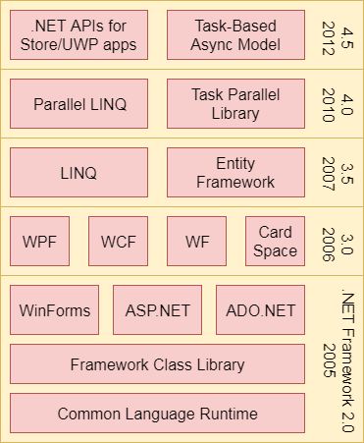

***CLR (Common Language Runtime):

It is a program execution engine that loads and executes the program. It converts the program into native code. It acts as an interface between the framework and operating system. It does exception handling, memory management, and garbage collection. Moreover, it provides security, type-safety, interoperability, and portablility. A list of CLR components are given below:

FCL (Framework Class Library)
It is a standard library that is a collection of thousands of classes and used to build an application. The BCL (Base Class Library) is the core of the FCL and provides basic functionalities.
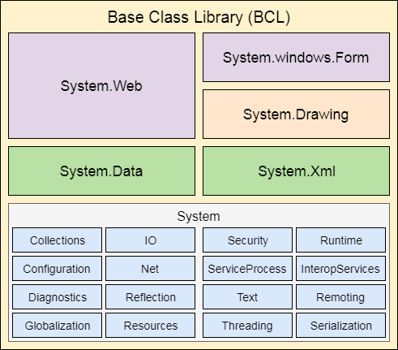

NOT very imp so only quick veiw of these five term.

WinForms
Windows Forms is a smart client technology for the .NET Framework, a set of managed libraries that simplify common application tasks such as reading and writing to the file system.

ASP.NET
ASP.NET is a web framework designed and developed by Microsoft. It is used to develop websites, web applications, and web services. It provides a fantastic integration of HTML, CSS, and JavaScript. It was first released in January 2002.

ADO.NET
ADO.NET is a module of .Net Framework, which is used to establish a connection between application and data sources. Data sources can be such as SQL Server and XML. ADO .NET consists of classes that can be used to connect, retrieve, insert, and delete data.

WPF (Windows Presentation Foundation)
Windows Presentation Foundation (WPF) is a graphical subsystem by Microsoft for rendering user interfaces in Windows-based applications. WPF, previously known as "Avalon", was initially released as part of .NET Framework 3.0 in 2006. WPF uses DirectX.

WCF (Windows Communication Foundation)
It is a framework for building service-oriented applications. Using WCF, you can send data as asynchronous messages from one service endpoint to another.

WF (Workflow Foundation)
Windows Workflow Foundation (WF) is a Microsoft technology that provides an API, an in-process workflow engine, and a rehostable designer to implement long-running processes as workflows within .NET applications.

LINQ (Language Integrated Query)
It is a query language, introduced in .NET 3.5 framework. It is used to make the query for data sources with C# or Visual Basics programming languages

Entity Framework
It is an ORM based open source framework which is used to work with a database using .NET objects. It eliminates a lot of developers effort to handle the database. It is Microsoft's recommended technology to deal with the database.

Parallel LINQ
Parallel LINQ or PLINQ is a parallel implementation of LINQ to objects. It combines the simplicity and readability of LINQ and provides the power of parallel programming.
It can improve and provide fast speed to execute the LINQ query by using all available computer capabilities.

***.NET Common Language Runtime (CLR)
.NET CLR is a run-time environment that manages and executes the code written in any .NET programming language.
It converts code into native code which further can be executed by the CPU.

***.NET CLR Functions
Following are the functions of the CLR.
It converts the program into native code.
1_Handles Exceptions, 2_Provides type-safety, 3_Memory management, 4_Provides security, 5_Improved performance, 6_Language independent, 7_Platform independent, 8_Garbage collection, 9_Provides language features such as inheritance, interfaces, and overloading for object-oriented programmings.
.NET CLR Versions
First version is beta and latest is 4.6
.NET CLR Structure

Following is the component structure of Common Language Runtime
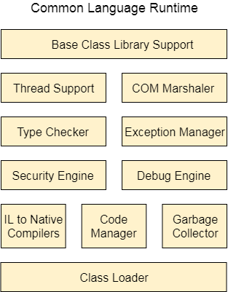
Base Class Library Support
It is a class library that provides support of classes to the .NET application.
Thread Support
It manages the parallel execution of the multi-threaded application.
COM Marshaler
It provides communication between the COM objects and the application.
Type Checker
It checks types used in the application and verifies that they match to the standards provided by the CLR.
Code Manager
It manages code at execution run-time.
Garbage Collector
It releases the unused memory and allocates it to a new application.
Exception Handler
It handles the exception at runtime to avoid application failure.
ClassLoader
It is used to load all classes at run time.

***.NET Framework Class Library
.NET Framework Class Library is the collection of classes, namespaces, interfaces and value types that are used for .NET applications.
It contains thousands of classes that supports the following functions.
- Base and user-defined data types
- Support for exceptions handling
- input/output and stream operations
- Communications with the underlying system
- Access to data
- Ability to create Windows-based GUI applications
- Ability to create web-client and server applications
- Support for creating web services

***What is Just-In-Time(JIT) Compiler in .NET
Just-In-Time compiler(JIT) is a part of Common Language Runtime (CLR) in .NET which is responsible for managing the execution of.NET programs regardless of any.NET programming language. A language-specific compiler converts the source code to the intermediate language. This intermediate language is then converted into the machine code by the Just-In-Time (JIT) compiler. This machine code is specific to the computer environment that the JIT compiler runs on.
Working of JIT Compiler: The JIT compiler is required to speed up the code execution

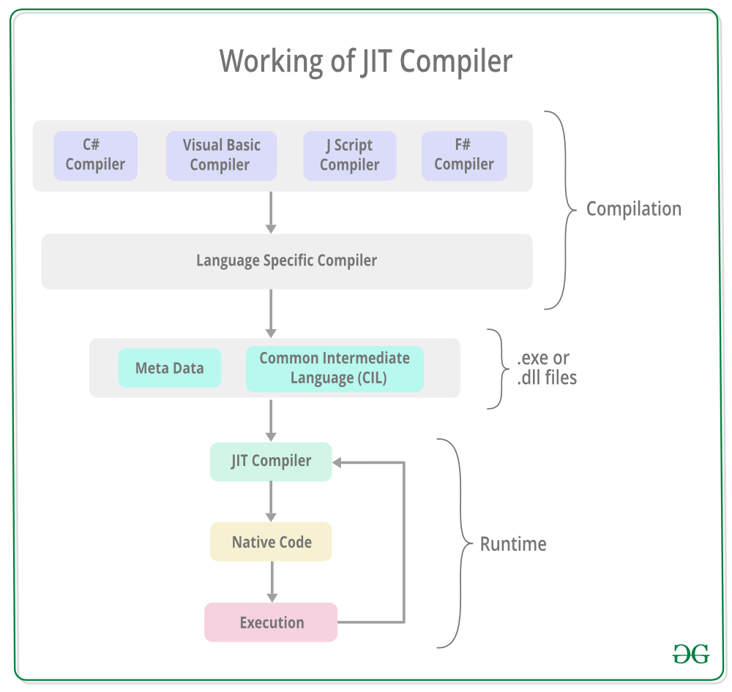

The JIT compiler converts the Microsoft Intermediate Language(MSIL) or Common Intermediate Language(CIL) into the machine code. This is done before the MSIL or CIL can be executed. The MSIL is converted into machine code on a requirement basis i.e. the JIT compiler compiles the MSIL or CIL as required rather than the whole of it. The compiled MSIL or CIL is stored so that it is available for subsequent calls if required.
Only go throught quickly not need to learn all types

Types of Just-In-Time Compiler:There are 3 types of JIT compilers which are as follows:-
1 Pre-JIT Compiler:All the source code is compiled into the machine code at the same time in a single compilation cycle using the Pre-JIT Compiler. This compilation process is performed at application deployment time. And this compiler is always implemented in theNgen.exe (Native Image Generator).

2_Normal JIT Compiler:The source code methods that are required at run-time are compiled into machine code the first time they are called by the Normal JIT Compiler. After that, they are stored in the cache and used whenever they are called again.
3_Econo JIT Compiler:The source code methods that are required at run-time are compiled into machine code by the Econo JIT Compiler. After these methods are not required anymore, they are removed. This JIT compiler is obsolete starting from dotnet 2.0

=================================================================================
******PROCESS:-we will understand the execution process of .NET Core and compare it with the .NET Framework. The managed execution process includes the following steps.
- Choosing a compiler
- Compiling your code to MSIL
- Compiling MSIL to native code
- Running code
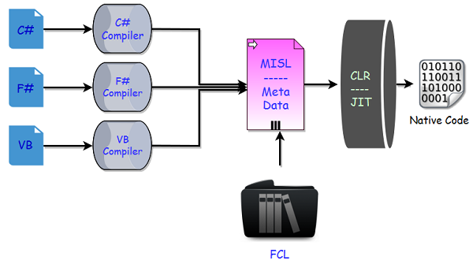

Choosing a Compiler
- It is a multi-language execution environment, the runtime supports a wide variety of data types and language features.
- To obtain the benefits provided by the common language runtime, you must use one or more language compilers that target the runtime.

Compiling your code to MSIL
- Compiling translates your source code into Microsoft Intermediate Language (MSIL) and generates the required metadata.
- Metadata describes the types in your code, including the definition of each type, the signatures of each type's members, the members that your code references, and other data that the runtime uses at execution time.
- The runtime locates and extracts the metadata from the file as well as from framework class libraries (FCL) as needed during execution.

Compiling MSIL to Native Code
- At execution time, a just-in-time (JIT) compiler translates the MSIL into native code.
- During this compilation, code must pass a verification process that examines the MSIL and metadata to find out whether the code can be determined to be type safe.

Running Code
- The common language runtime provides the infrastructure that enables the execution to take place and services that can be used during execution.
- During execution, managed code receives services such as garbage collection, security, interoperability with unmanaged code, cross-language debugging support, and enhanced deployment and versioning support.

***.NET Core Code Execution Process
Now let’s relate how code executes with .NET Core as compared to .NET Framework. In .NET Core there are many replacements of these components that are the part of the .NET Framework.
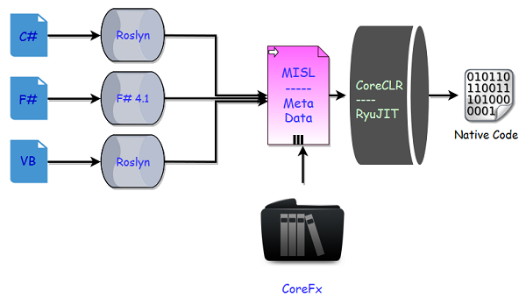
- In .NET Core now we have a new series of compilers, like we have Roslyn for C# and VB.
- You can also make use of the new F# 4.1 compiler if you want to use F# with .NET Core.
- Actually these tools are different and we can use Roslyn with .NET Framework as well if we are using C# 6 or later, because C# compiler can only support up to C# 5.
- In .NET Core, we don’t have a framework class libraries (FCL), so a different set of libraries are used and we now have CoreFx.
- CoreFx is the reimplementation of the class libraries for .NET Core.
- We also have a new run time with .NET Core known as CoreCLR and leverages a JIT Compiler.
- Now the question is why do we have the reimplementation of all these components that we already have in .NET framework.
- So the answer is the same as why Microsoft implemented .NET Core.
What is Metadate?
Metadata allows us to write a component in C# and let another application use the metadata from Visual Basic . NET. The metadata description of a type allows the runtime to layout an object in memory, to enforce security and type safety, and ensure version compatibilities.
CTS (Common Type System)
It specifies a standard that represent what type of data and value can be defined and managed in computer memory at runtime. A CTS ensures that programming data defined in various languages should beinteract with each other to share information. For example, in C# we define data type as int, while in VB.NET we define integer as a data type.
****What is Unified class?
The Unified Classes (Base Class Library) is a set of classes that provide useful functionality to CLR programmers. The .NET Framework class library exposes features of the runtime and simplifies the development of .NET-based applications. All applications (Web, Windows, and XML Web services) access the same .NET Framework class libraries, which are held in namespaces. All .NET-based languages also access the same libraries.
*****C# | Boxing And Unboxing
Boxing and unboxing is an important concept in C#. C# Type System contains three data typesValue Types (int, char, etc),Reference Types (object)and Pointer Types. Basically it convert a Value Type to a Reference Type, and vice versa. Boxing and Unboxing enables a unified view of the type system in which a value of any type can be treated as an object.

Boxing In C#
- The process of Converting a Value Type(char, int etc.) to a Reference Type(object) is called Boxing.
- Boxing is implicit conversion process in which object type (super type) is used.
- The Value type is always stored in Stack. The Referenced Type is stored in Heap.
- Example :
int num = 23; // 23 will assigned to num
Object Obj = num; // Boxing
- Description :First declare a value type variable (num), which is integer type and assigned it with value 23. Now create a references object type (obj) and applied Explicit operation which results in num value type to be copied and stored in object reference type obj as shown in below figure :
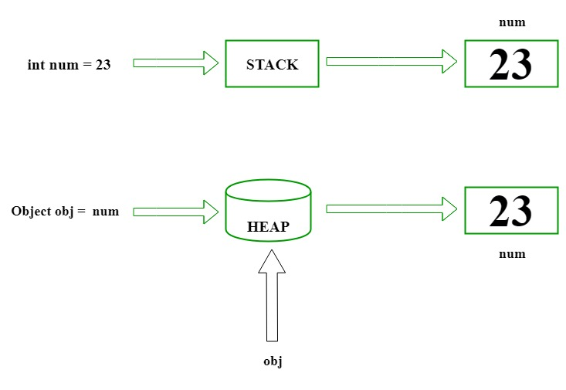
- Let’s understand Boxing with a C# programming code :
// C# implementation to demonstrate
// the Boxing
using System;
class GFG {

// Main Method
static public void Main()
{

// assigned int value
// 2020 to num
int num = 2020;

// boxing
object obj = num;

// value of num to be change
num = 100;

System.Console.WriteLine
("Value - type value of num is : {0}", num);
System.Console.WriteLine
("Object - type value of obj is : {0}", obj);
}
}

Output:
Value - type value of num is : 100
Object - type value of obj is : 2020

Unboxing In C#

- The process of converting reference type into the value type is known asUnboxing.
- It is explicit conversion process.

- Example :
int num = 23; // value type is int and assigned value 23
Object Obj = num; // Boxing
int i = (int)Obj; // Unboxing
- Description : Declaration a value type variable (num), which is integer type and assigned with integer value 23. Now, create a reference object type (obj).The explicit operation for boxing create an value type integer i and applied casting method. Then the referenced type residing on Heap is copy to stack as shown in below figure :
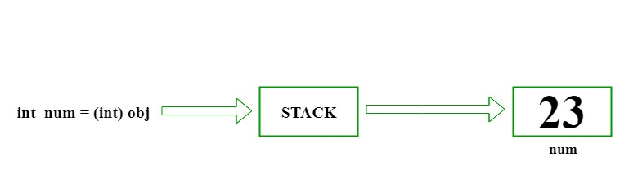
- Let’s understand Unboxing with a C# programming code :
// C# implementation to demonstrate
// the Unboxing
using System;
class GFG {

// Main Method
static public void Main()
{

// assigned int value
// 23 to num
int num = 23;

// boxing
object obj = num;

// unboxing
int i = (int)obj;

// Display result
Console.WriteLine("Value of ob object is : " + obj);
Console.WriteLine("Value of i is : " + i);
}
}

Output:
Value of ob object is : 23
Value of i is : 23
What is C#?
C# is pronounced as "C-Sharp". It is an object-oriented programming language provided by Microsoft that runs on .Net Framework.
By the help of C# programming language, we can develop different types of secured and robust applications:
- Window applications
- Web applications
- Distributed applications
- Web service applications
- Database applications etc.
C# is approved as a standard by ECMA and ISO. C# is designed for CLI (Common Language Infrastructure). CLI is a specification that describes executable code and runtime environment.
C# programming language is influenced by C++, Java, Eiffel, Modula-3, Pascal etc. Languages.

C# Features
C# is object oriented programming language. It provides a lot of features that are given below.
- Simple
- Modern programming language
- Object oriented
- Type safe
- Interoperability
- Scalable and Updateable
- Component oriented
- Structured programming language
- Rich Library
- Fast speed

C# Variable
A variable is a name of memory location. It is used to store data.
Decimal types decimal, Boolean types True or false value, Integral typesint, char, byte, short,etc

Rules for defining variables
A variable can have alphabets, digits and underscore.
A variable name can start with alphabet and underscore only. It can't start with digit.
No white space is allowed within variable name.
A variable name must not be any reserved word or keyword e.g. char, float etc.

C# Data Types
A data type specifies the type of data that a variable can store such as integer, floating, character etc.
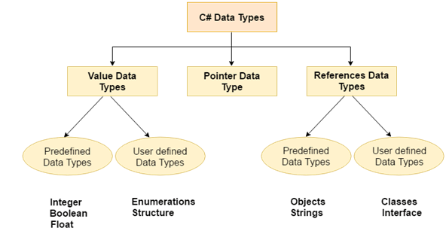

The reference data types do not contain the actual data stored in a variable, but they contain a reference to the variables.
Quick review no need to learn
If the data is changed by one of the variables, the other variable automatically reflects this change in value.
There are 2 types of reference data type in C# language.
1) Predefined Types - such as Objects, String.
2) User defined Types - such as Classes, Interface.

C# operators
An operator is simply a symbol that is used to perform operations.
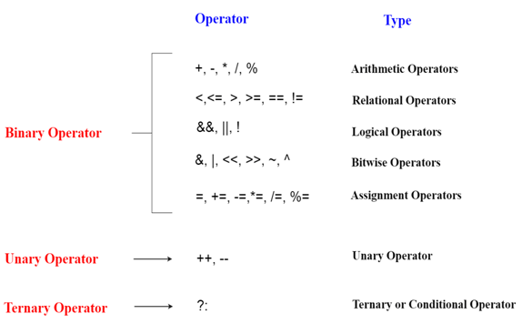

*****Control Statements

C# if-else
In C# programming, the if statement is used to test the condition. There are various types of if statements in C#.
- if statement
- if-else statement
- nested if statement
- if-else-if ladder
if(condition){
//code tobeexecuted
}else {
//condition if false
}

C# switch
The C# switch statement executes one statement from multiple conditions. It is like if-else-if ladder statement in C#
switch(expression){
casevalue1:
//code tobeexecuted;
break;
case value2:
//code to be executed;
break;
- ......
default:
//code to be executed if all cases are not matched;
break;
}

C# loops
for-The C# for loop is used to iterate a part of the program several times.
Foreach -to iterate or teversing each of element
do-while-The C# do-while loop is used to iterate a part of the program several times. If the number of iteration is not fixed and you must have to execute the loop at least once, it is recommended to use do-while loop
while loops -it run untill or unless single condition not false

C# Comments
The C# comments are statements that are not executed by the compiler.
Single Line comment-//hsdjshdkdjd
Multi Line comment-/*shkdhdkl skjsljnxslxk */

C# Object and Class
Since C# is an object-oriented language, program is designed using objects and classes in C#.

C# Object and Class
Since C# is an object-oriented language, program is designed using objects and classes in C#.

C# Object
In C#, Object is a real world entity, for example, chair, car, pen, mobile, laptop etc.
In other words, object is an entity that has state and behavior. Here, state means data and behavior means functionality.
Object is a runtime entity, it is created at runtime.
Object is an instance of a class. All the members of the class can be accessed through object.
Let's see an example to create object using new keyword.
- Student s1=new Student();//creating an object of Student

C# Class
In C#, class is a group of similar objects. It is a template from which objects are created. It can have fields, methods, constructors etc.
Let's see an example of C# class that has two fields only.
public class Student
{
int id;//field or data member
Stringname;//fieldordata member
}

C# Constructor
In C#, constructor is a special method which is invoked automatically at the time of object creation. It is used to initialize the data members of new object generally. The constructor in C# has the same name as class or struct.
There can be two types of constructors in C#.
- Default constructor-
A constructor which has no argument is known as default constructor. It is invoked at the time of creating object

- Parameterized constructor
A constructor which has parameters is called parameterized constructor. It is used to provide different values to distinct objects.

C# Destructor
A destructor works opposite to constructor, It destructs the objects of classes. It can be defined only once in a class. Like constructors, it is invoked automatically.
Example ~Employee()

C# this
In c# programming, this is a keyword that refers to the current instance of the class. There can be 3 main usage of this keyword in C#.
- It can be used to refer current class instance variable. It is used if field names (instance variables) and parameter names are same, that is why both can be distinguish easily.
- It can be used to pass current object as a parameter to another method.
- It can be used to declare indexers.

C# static
In C#, static is a keyword or modifier that belongs to the type not instance. So instance is not required to access the static members. In C#, static can be field, method, constructor, class, properties, operator and event.

Advantage of C# static keyword
Memory efficient: Now we don't need to create instance for accessing the static members, so it saves memory. Moreover, it belongs to the type, so it will not get memory each time when instance is created.

C# static class
The C# static class is like the normal class but it cannot be instantiated. It can have only static members. The advantage of static class is that it provides you guarantee that instance of static class cannot be created.

Points to remember for C# static class
- C# static class contains only static members.
- C# static class cannot be instantiated.
- C# static class is sealed.
- C# static class cannot contain instance constructors.
sing System;
public static class MyMath
{
public static float PI=3.14f;
public static int cube(int n){return n*n*n;}
}
class TestMyMath{
public static void Main(string []args)
{
Console.WriteLine("Value of PI is:"+MyMath.PI);
Console.WriteLine("Cube of 3 is:“+MyMath.cube(3));
}
}

***C# Strings
In C#, string is an object of System.String class that represent sequence of characters. We can perform many operations on strings such as concatenation, comparision, getting substring, search, trim, replacement etc.

string vs String
In C#, string is keyword which is an alias for System.String class. That is why string and String are equival

C# String methods
***learn only for to five
Method Name | Description
Clone() | It is used to return a reference to this instance of String.
Compare(String, String) | It is used to compares two specified String objects. It returns an integer that indicates their relative position in the sort order.
CompareOrdinal(String, String) | It is used to compare two specified String objects by evaluating the numeric values of the corresponding Char objects in each string..
CompareTo(String) | It is used to compare this instance with a specified String object. It indicates whether this instance precedes, follows, or appears in the same position in the sort order as the specified string.
Concat(String, String) | It is used to concatenate two specified instances of String.
Contains(String) | It is used to return a value indicating whether a specified substring occurs within this string.
Copy(String) | It is used to create a new instance of String with the same value as a specified String.
CopyTo(Int32, Char[], Int32, Int32) | It is used to copy a specified number of characters from a specified position in this instance to a specified position in an array of Unicode characters.
EndsWith(String) | It is used to check that the end of this string instance matches the specified string.
Equals(String, String) | It is used to determine that two specified String objects have the same value.
Format(String, Object) | It is used to replace one or more format items in a specified string with the string representation of a specified object.
GetEnumerator() | It is used to retrieve an object that can iterate through the individual characters in this string.
GetHashCode() | It returns the hash code for this string.
GetType() | It is used to get the Type of the current instance.
GetTypeCode() | It is used to return the TypeCode for class String.
IndexOf(String) | It is used to report the zero-based index of the first occurrence of the specified string in this instance.
Insert(Int32, String) | It is used to return a new string in which a specified string is inserted at a specified index position.
Intern(String) | It is used to retrieve the system's reference to the specified String.
IsInterned(String) | It is used to retrieve a reference to a specified String.
IsNormalized() | It is used to indicate that this string is in Unicode normalization form C.
IsNullOrEmpty(String) | It is used to indicate that the specified string is null or an Empty string.
IsNullOrWhiteSpace(String) | It is used to indicate whether a specified string is null, empty, or consists only of white-space characters.
Join(String, String[]) | It is used to concatenate all the elements of a string array, using the specified separator between each element.
LastIndexOf(Char) | It is used to report the zero-based index position of the last occurrence of a specified character within String.
LastIndexOfAny(Char[]) | It is used to report the zero-based index position of the last occurrence in this instance of one or more characters specified in a Unicode array.
Normalize() | It is used to return a new string whose textual value is the same as this string, but whose binary representation is in Unicode normalization form C.
PadLeft(Int32) | It is used to return a new string that right-aligns the characters in this instance by padding them with spaces on the left.
PadRight(Int32) | It is used to return a new string that left-aligns the characters in this string by padding them with spaces on the right.
Remove(Int32) | It is used to return a new string in which all the characters in the current instance, beginning at a specified position and continuing through the last position, have been deleted.
Replace(String, String) | It is used to return a new string in which all occurrences of a specified string in the current instance are replaced with another specified string.
Split(Char[]) | It is used to split a string into substrings that are based on the characters in an array.
StartsWith(String) | It is used to check whether the beginning of this string instance matches the specified string.
Substring(Int32) | It is used to retrieve a substring from this instance. The substring starts at a specified character position and continues to the end of the string.
ToCharArray() | It is used to copy the characters in this instance to a Unicode character array.
ToLower() | It is used to convert String into lowercase.
ToLowerInvariant() | It is used to return convert String into lowercase using the casing rules of the invariant culture.
ToString() | It is used to return instance of String.
ToUpper() | It is used to convert String into uppercase.
Trim() | It is used to remove all leading and trailing white-space characters from the current String object.
TrimEnd(Char[]) | It Is used to remove all trailing occurrences of a set of characters specified in an array from the current String object.
TrimStart(Char[]) | It is used to remove all leading occurrences of a set of characters specified in an array from the current String object.
C# Arrays
Like other programming languages, array in C# is a group of similar types of elements that have contiguous memory location. In C#, array is an object of base type System.Array. In C#, array index starts from 0. We can store only fixed set of elements in C# array.

Advantages of C# Array
- Code Optimization (less code)
- Random Access
- Easy to traverse data
- Easy to manipulate data
- Easy to sort data etc.

Disadvantages of C# Array
- Fixed size
There are 3 types of arrays in C# programming:
- Single Dimensional Array
- Multidimensional Array
- Jagged Array

C# Command Line Arguments
Arguments that are passed by command line known as command line arguments. We can send arguments to the Main method while executing the code. The string args variable contains all the values passed from the command line.
int[] arr = new int[5];//creating array

C# Multidimensional Arrays
The multidimensional array is also known as rectangular arrays in C#. It can be two dimensional or three dimensional. The data is stored in tabular form (row * column) which is also known as matrix.
To create multidimensional array, we need to use comma inside the square brackets. For example:
- int[,]arr=new int[3,3];//declaration of 2D array
- int[,,] arr=new int[3,3,3];//declaration of 3D array

C# Multidimensional Array Example
Let's see a simple example of multidimensional array in C# which declares, initializes and traverse two dimensional array.

- using System;
- public class MultiArrayExample
- {
- public static void Main(string[] args)
- {
- int[,] arr=new int[3,3];//declaration of 2D array
- arr[0,1]=10;//initialization
- arr[1,2]=20;
- arr[2,0]=30;

- //traversal
- for(int i=0;i<3;i++){
- for(int j=0;j<3;j++){
- Console.Write(arr[i,j]+" ");
- }
- Console.WriteLine();//new line at each row
- }
- }
- }
Output:
0 10 0
0 0 20
30 0 0

C# Multidimensional Array Example: Declaration and initialization at same time
There are 3 ways to initialize multidimensional array in C# while declaration.
- int[,] arr = new int[3,3]= { { 1, 2, 3 }, { 4, 5, 6 }, { 7, 8, 9 } };
We can omit the array size.
- int[,] arr = new int[,]{ { 1, 2, 3 }, { 4, 5, 6 }, { 7, 8, 9 } };
We can omit the new operator also.
- int[,] arr = { { 1, 2, 3 }, { 4, 5, 6 }, { 7, 8, 9 } };

C# Jagged Arrays
In C#, jagged array is also known as "array of arrays" because its elements are arrays. The element size of jagged array can be different.

Declaration of Jagged array
Let's see an example to declare jagged array that has two elements.
- int[][] arr = new int[2][];

Initialization of Jagged array
Let's see an example to initialize jagged array. The size of elements can be different.
Arr[0] = new int[4];
arr[1] = new int[6];

Initialization and filling elements in Jagged array
Let's see an example to initialize and fill elements in jagged array.
- arr[0] = new int[4] { 11, 21, 56, 78 };
- arr[1] = new int[6] { 42, 61, 37, 41, 59, 63 };
Here, size of elements in jagged array is optional. So, you can write above code as given below:
- arr[0] = new int[] { 11, 21, 56, 78 };
- arr[1] = new int[] { 42, 61, 37, 41, 59, 63 };

C# Jagged Array Example
Let's see a simple example of jagged array in C# which declares, initializes and traverse jagged arrays.
- public class JaggedArrayTest
- {
- public static void Main()
- {
- int[][] arr = new int[2][];// Declare the array

- arr[0] = new int[] { 11, 21, 56, 78 };// Initialize the array
- arr[1] = new int[] { 42, 61, 37, 41, 59, 63 };

- // Traverse array elements
- for (int i = 0; i < arr.Length; i++)
- {
for(int j = 0; j < arr[i].Length; j++)
{
System.Console.Write(arr[i][j]+" ");
}
System.Console.WriteLine();
}
}
}
Output:
11 21 56 78
42 61 37 41 59 63

